Docker Task -3
Task Description:
Create a custom docker image for nginx and deploy it using docker compose, where the volume bind mount should be at /var/opt/nginx location. Push the created custom docker image to your docker-hub.
=======================================================================
- Create a custom docker image for nginx: -
- Create an EC2 instance
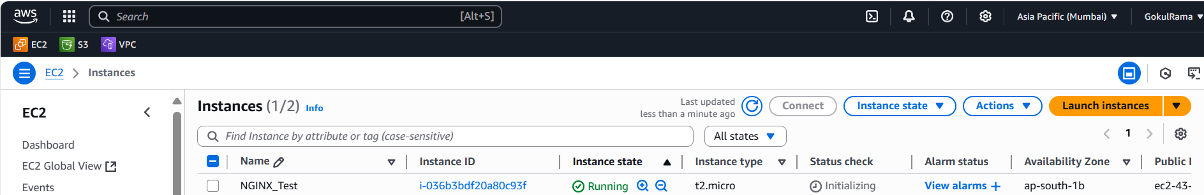

- Once created EC2, Click Connect and update latest libraries using the command is,
apt-get update

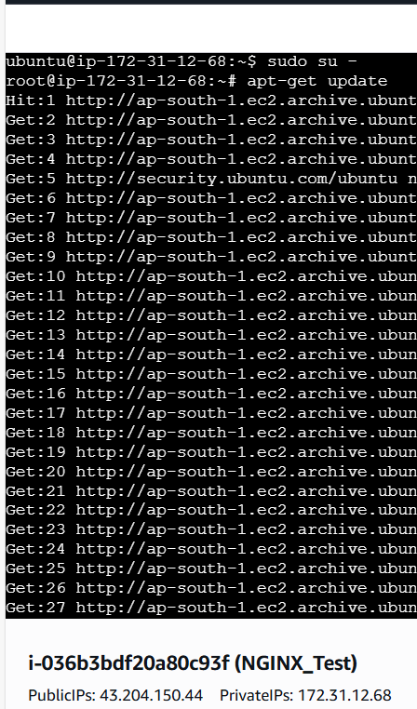

- Install docker in EC2 using this command is,
apt install docker.io -y
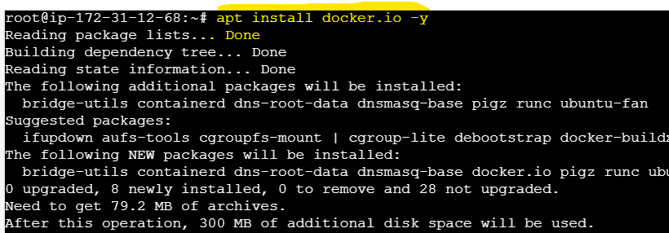
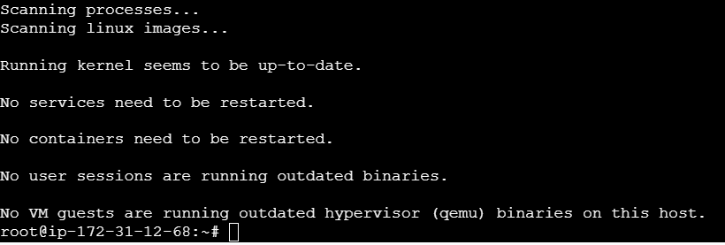

- Once installed docker successfully then check the version of docker using this command is,
docker --version
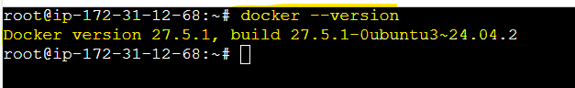

- Go to the below local path
- create one new folder [ Folder Name is DockerFile]
- Also, create one new file [File name is Dockerfile] without any file extension
(Basic Instructions to create docker image) inside the DockerFile Folder
- Command to create empty folder is
mkdir <Folder Name>
- Command to create empty file is
touch <File Name>
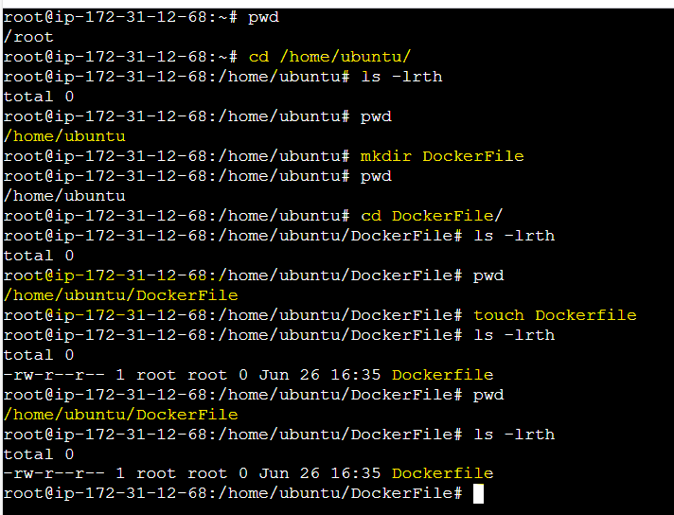
- Add the below instructions inside Dockerfile to create docker image 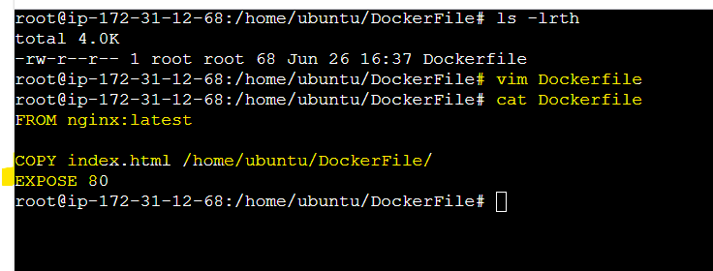
Instructions inside docker file is,
FROM nginx:latest

COPY index.html /home/ubuntu/DockerFile/
EXPOSED 80

- Create one new file [ File Name is index.html] inside the above created DockerFile folder
- Add the below html content in index.html file
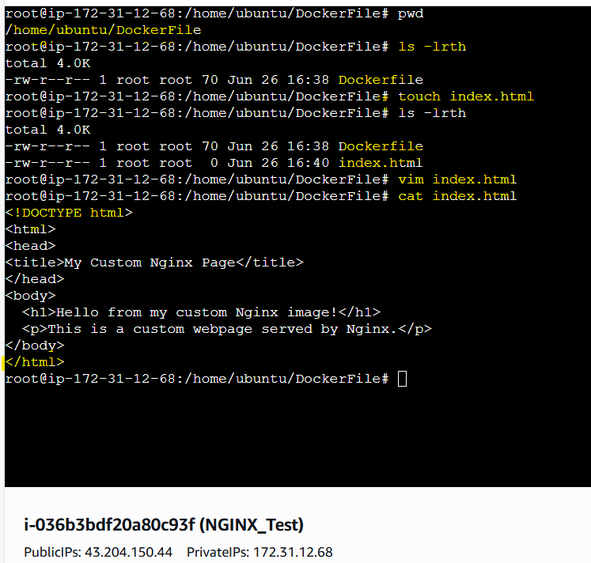

- Below command is to see the list of available docker images in EC2
docker images
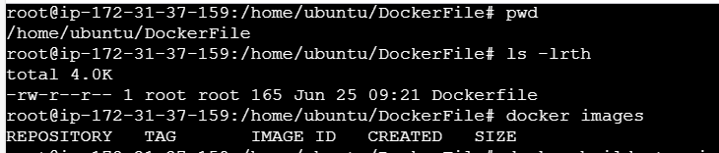

- Below command is to build docker image from docker hub and rename the image with proper name and give tag to the image
Docker build -t <image name>:<Tag Name> .
(or)
Docker build -t <image name> .

Here end of the command we need to mention “.” (dot). Dot refers current working directory
Note – docker build command is to build docker image based on the Dockerfile we
created already.
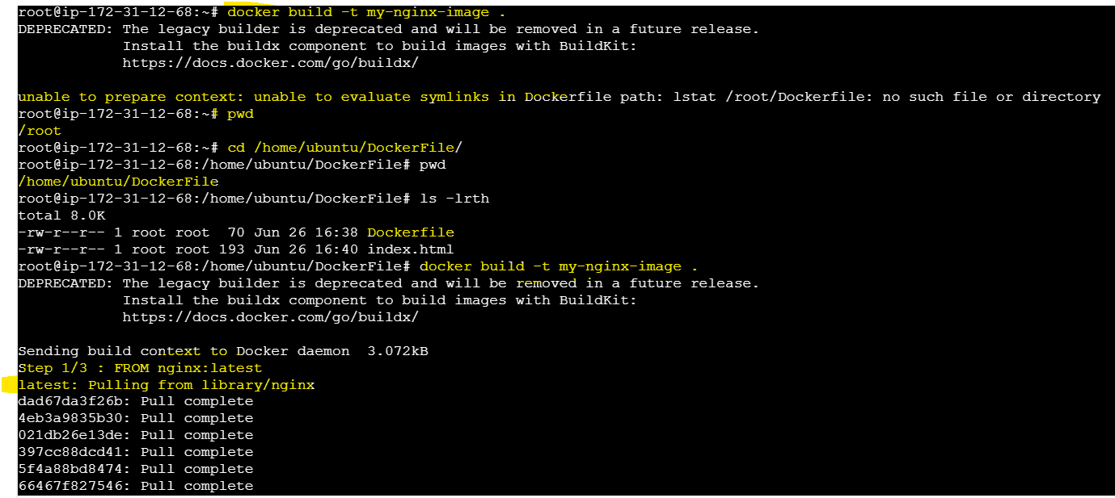
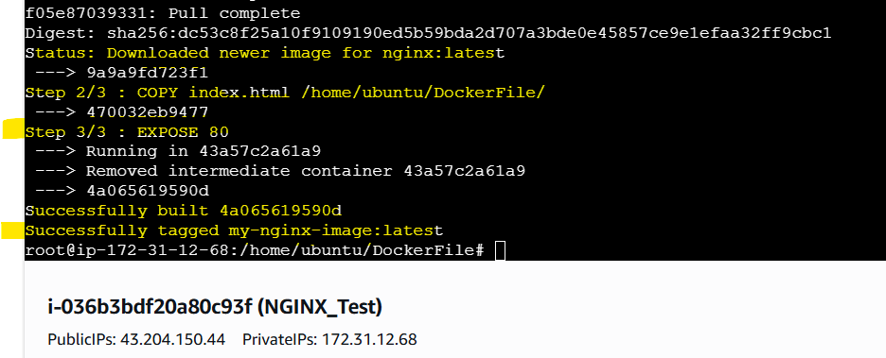

- Below command is to see the available docker images in EC2
docker images
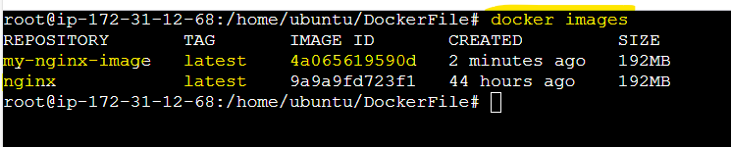

- Below command is to see the available docker containers in EC2
docker ps -a
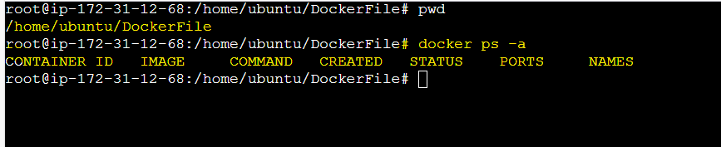

- To run docker container using the below command from DockerFile
Command is docker run -d -p 8080:80 <image name>

- Spin up the Docker Container: -
  - Hit the localhost with port getting this error. Reason is to add the port (8080) in inbound rules under EC2



- Test the connectivity using localhost,

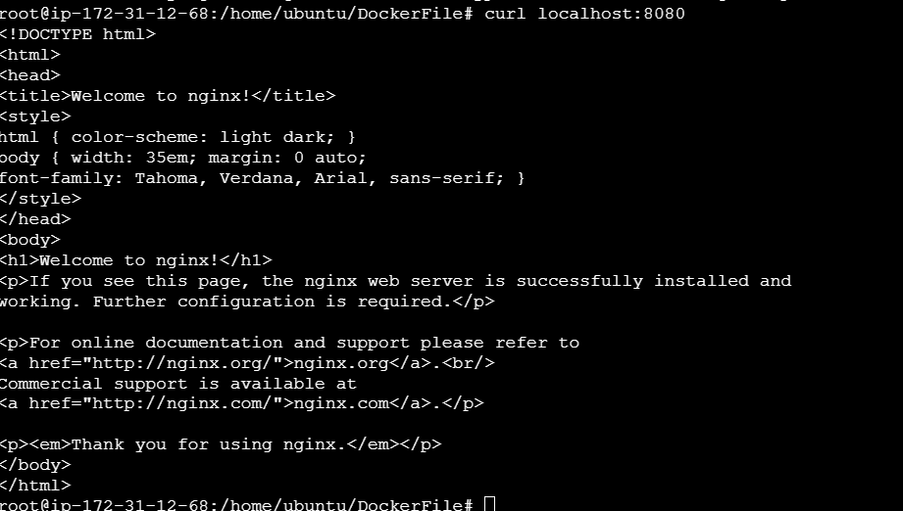

- In EC2 -> Security group -> Add new port: 8080
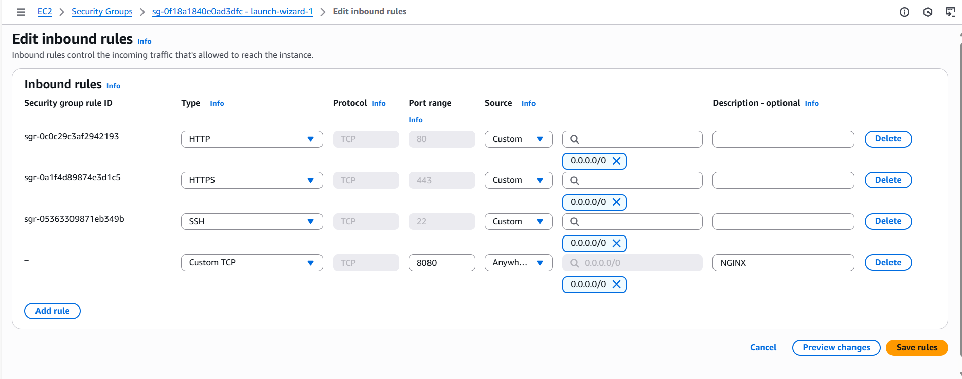

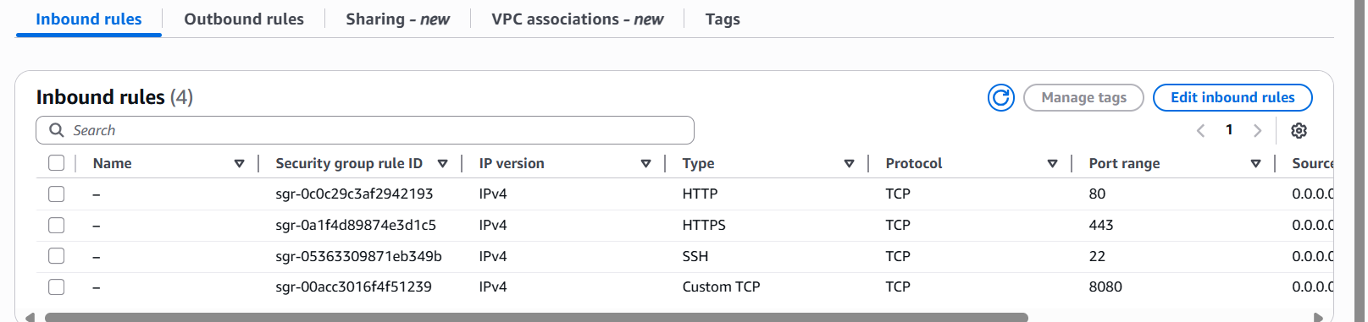

- Restart the container to reflect the above changes,
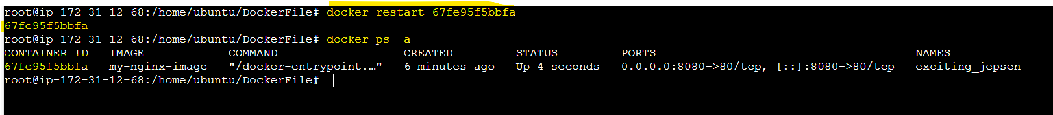
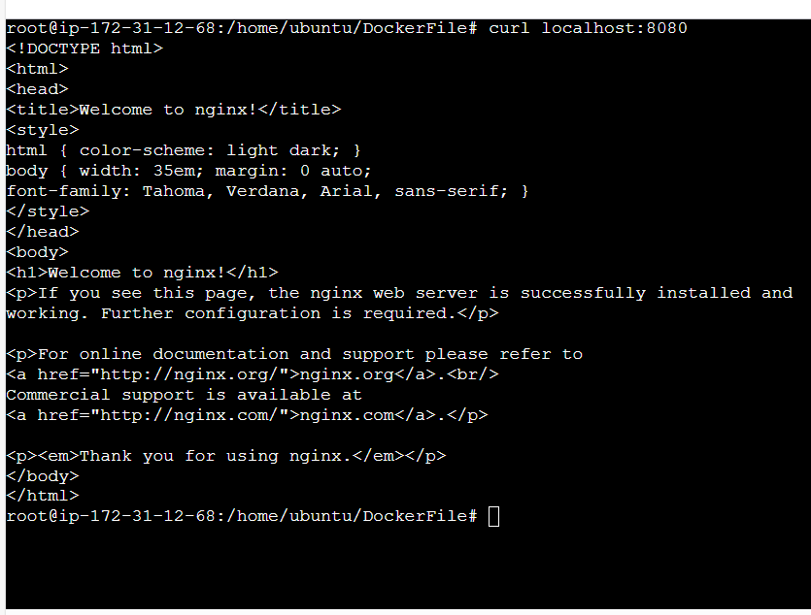

- To spin up the container hit the public URL with port (8080)
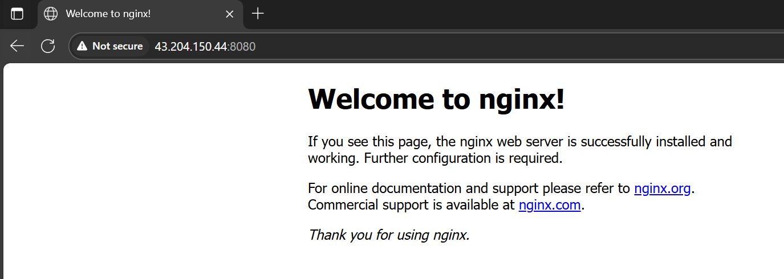

- Deploy NGINX using docker compose: -
2.1 Install Docker-Compose: -
- First check docker- compose is available or not using this below command,
docker-compose –version

- If the docker-compose is not available run the below command to install it
curl -SL https://github.com/docker/compose/releases/download/v2.37.2/docker-compose-linux-x86_64 -o /usr/local/bin/docker-compose
chmod +x /usr/local/bin/docker-compose

- Once executed the above commands then check the docker version using the below command,
docker-compose –version
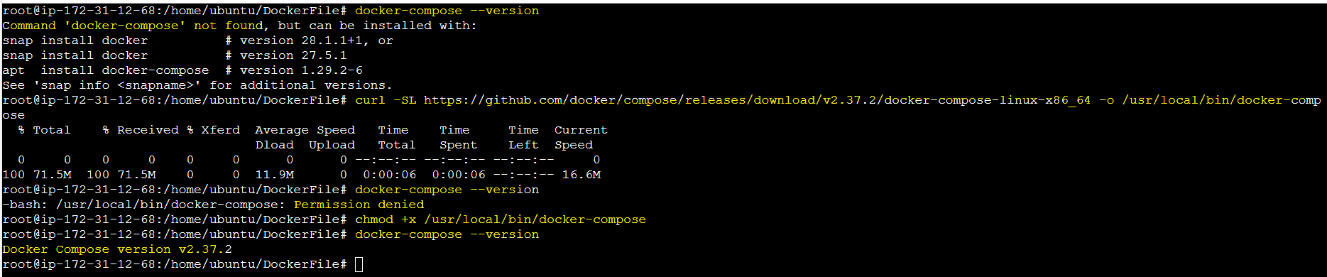

2.2 Create docker compose file: -
- Create empty directory in any path and directory name is DockerCompose,
mkdir <directory name>
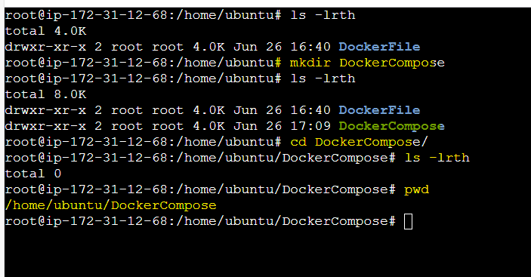

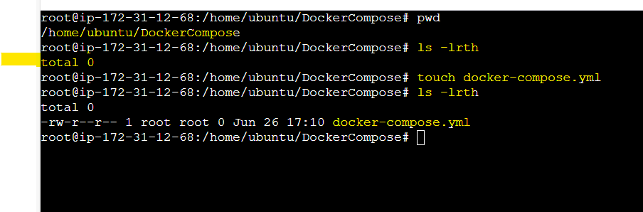

- Inside the above created directory, create docker-compose.yml file
- Add the below highlighted script inside docker-compose.yml file
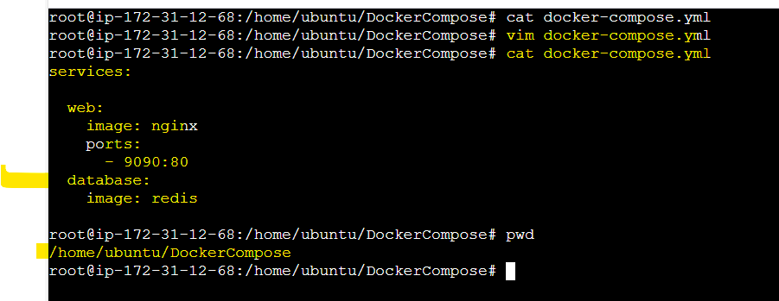

- Below command is to check the validity of the file,
Command is docker-compose config
Note: -
If the file is valid then the script executed without any error otherwise the config command is not executing and throw an error
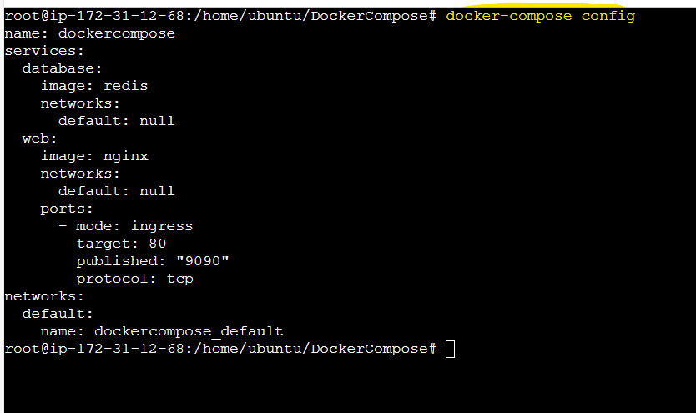

- Run docker-compose.yml file to pull the docker image from docker hub using the below command,
Docker-compose up -d
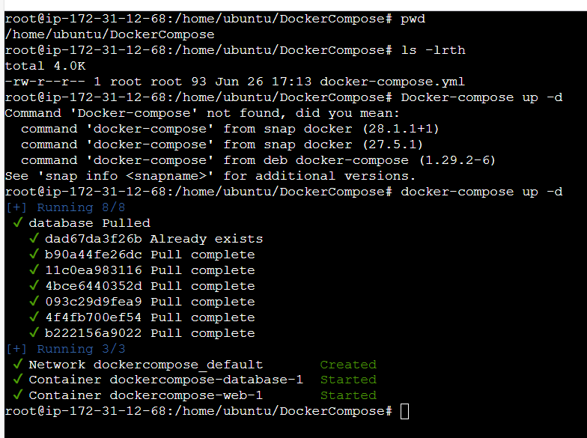

- Now check the docker images available in EC2 using the below command,
docker images
(or)
docker-compose ps
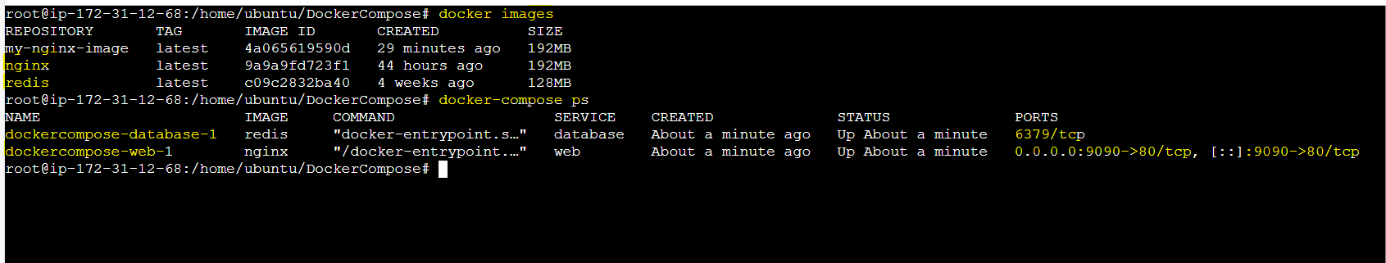

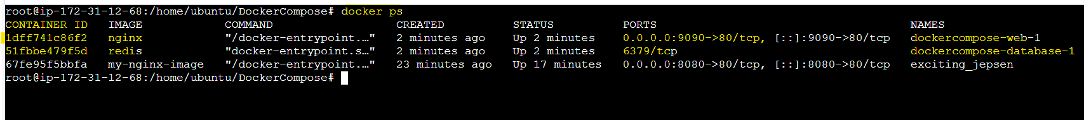

- Hit the public URL with respective port (9090 for nginx) to get nginx webpage
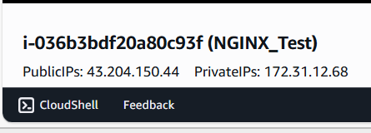

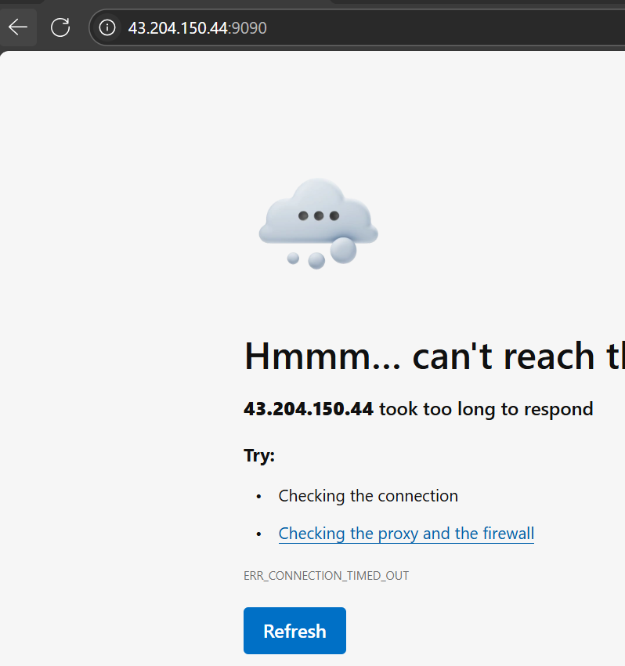

- In EC2 -> Security group -> Add new port: 9090
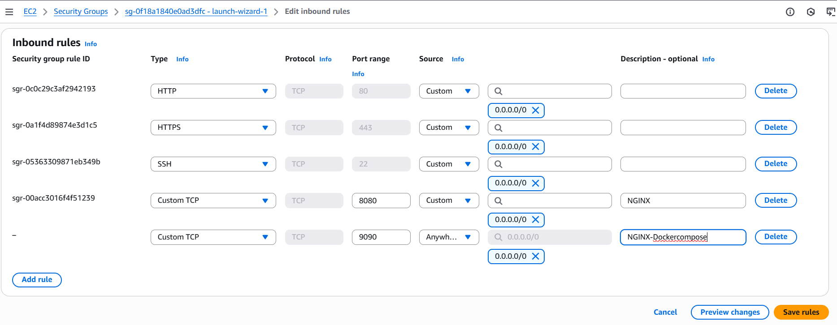

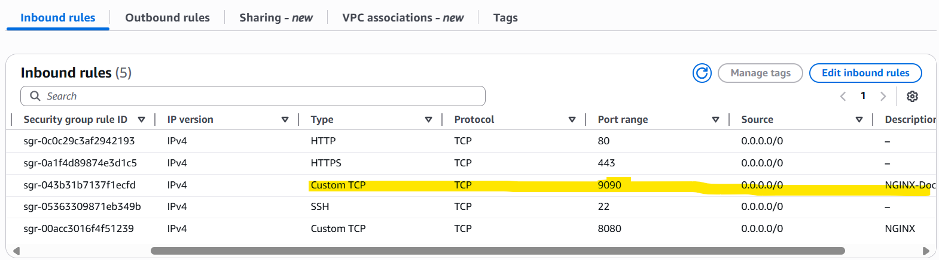

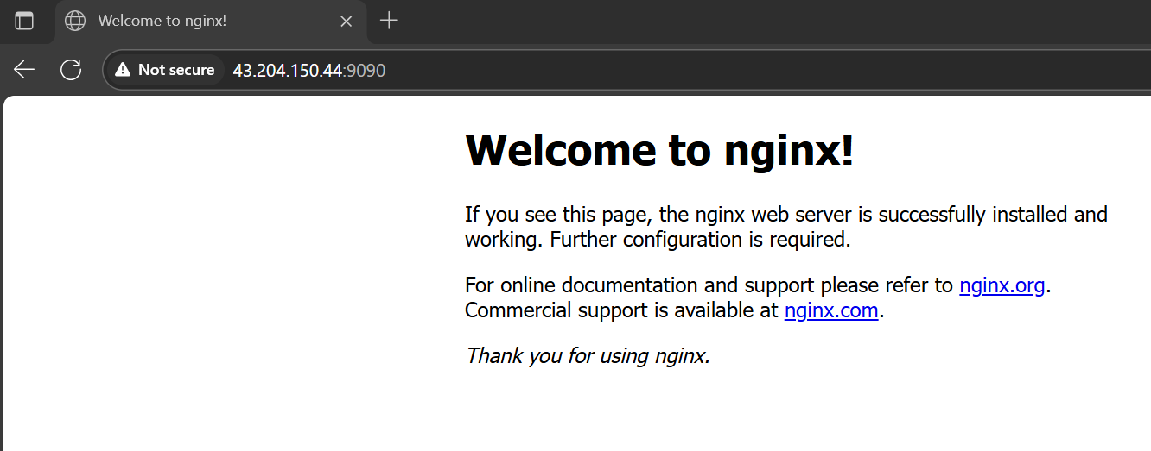
- Volume bind mount should be at /var/opt/nginx location: -

- Create EC2 instance
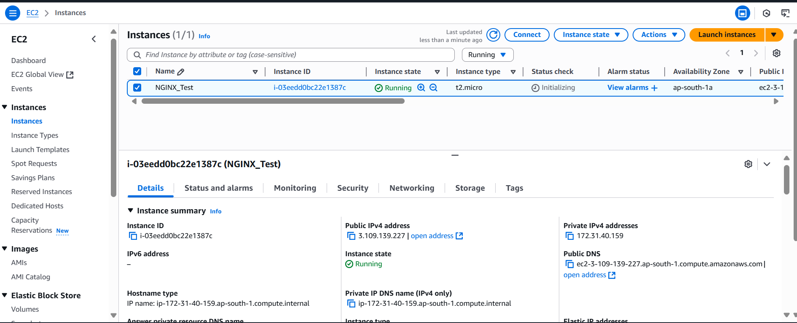

- Update libraries using the below command
apt-get update

- Install docker using the below command,
apt install docker.io -y
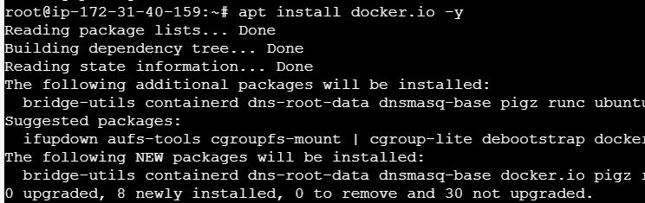

- Check the docker version using the below command,
Docker --version
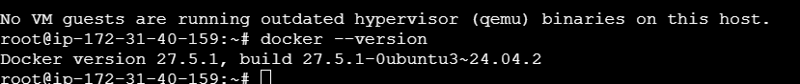

- Create empty directory using the below command,
mkdir <directoryname>

- Create empty yaml file using the below command,
touch <filename>
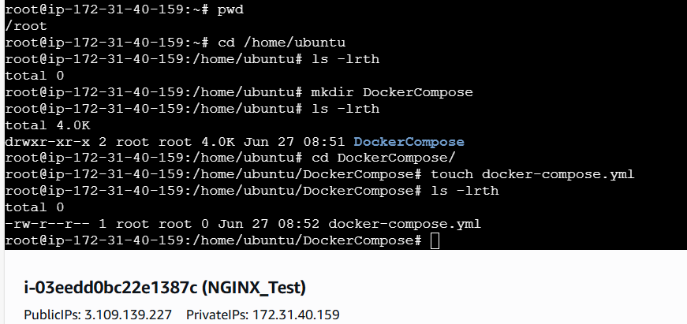

- Add the instruction inside the docker-compose.yml file
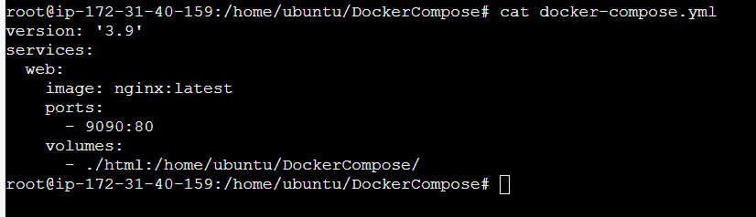

- List the images inside the docker – docker images
- List the containers inside the docker – docker ps
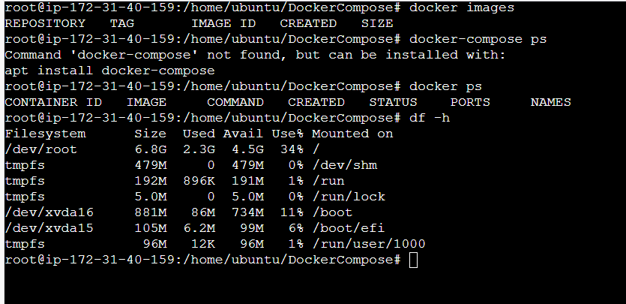
- Install docker-compose: -
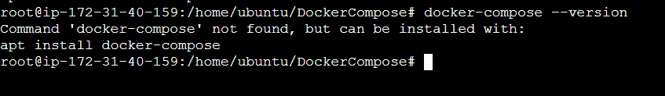

- If the docker-compose is not available run the below command to install it
curl -SL https://github.com/docker/compose/releases/download/v2.37.2/docker-compose-linux-x86_64 -o /usr/local/bin/docker-compose
chmod +x /usr/local/bin/docker-compose

- Once executed the above commands then check the docker version using the below command,
docker-compose –version
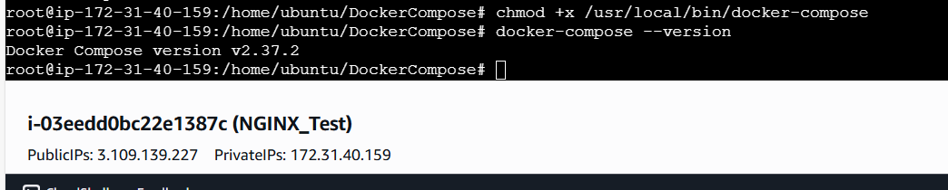

- Below command is to check the validity of the file,
Command is docker-compose config
Note: -
If the file is valid then the script executed without any error otherwise the config command is not executing like below and throw an error
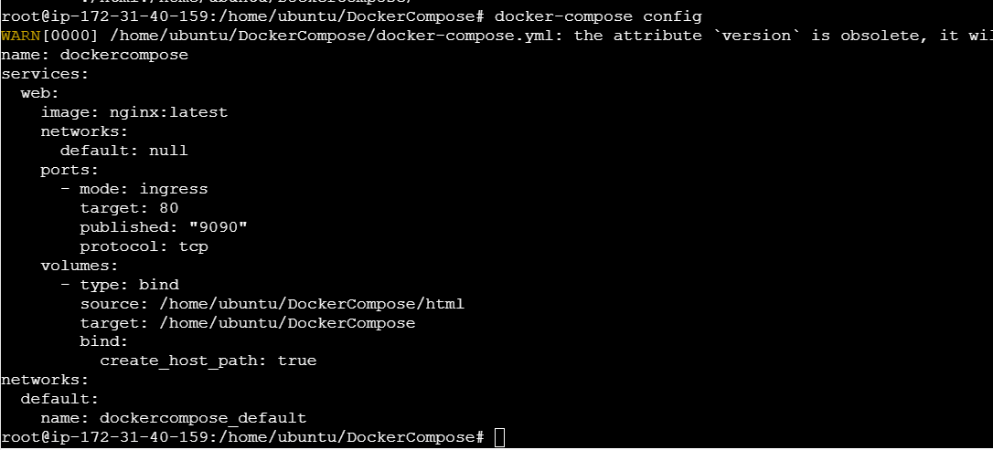

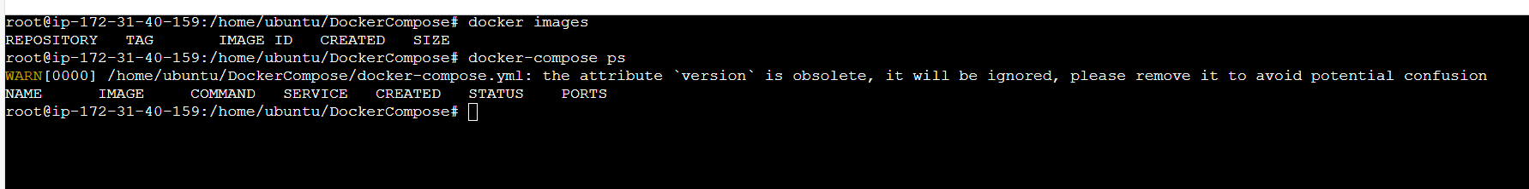

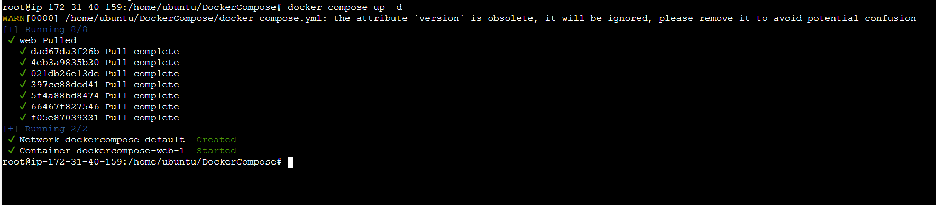

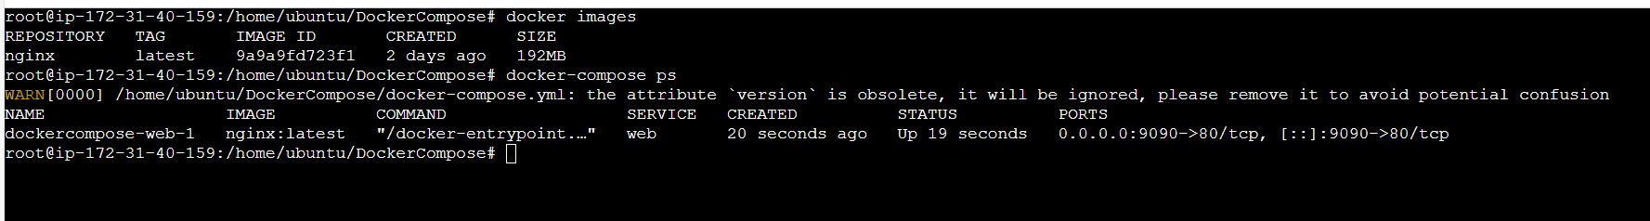

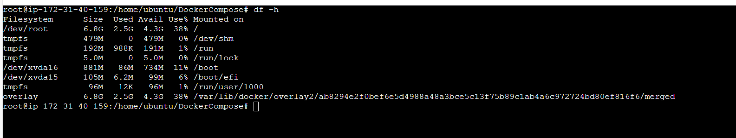

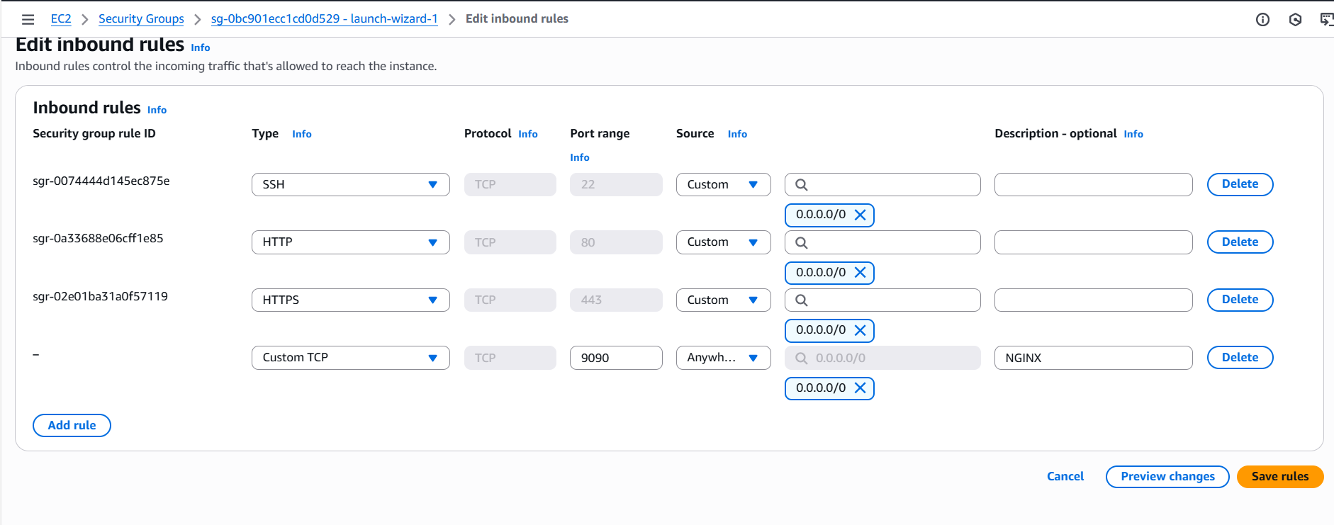

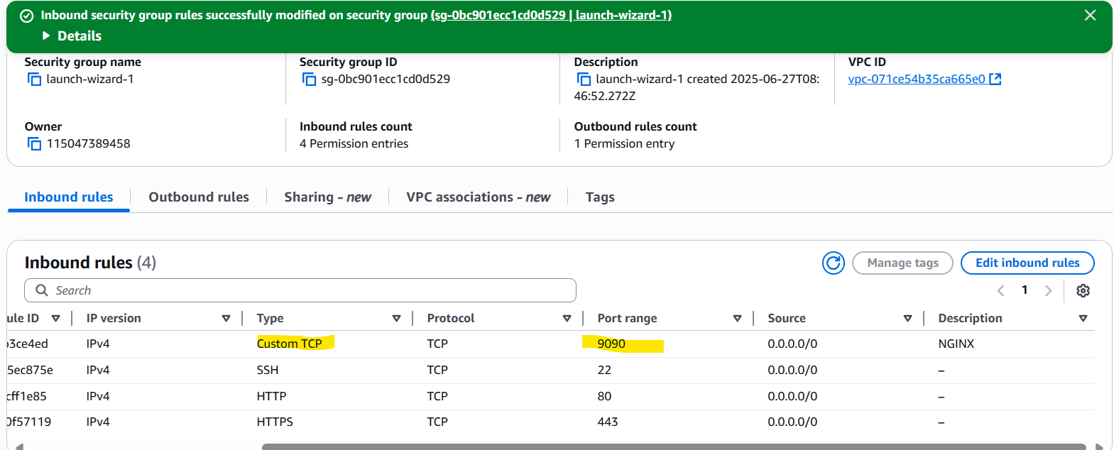

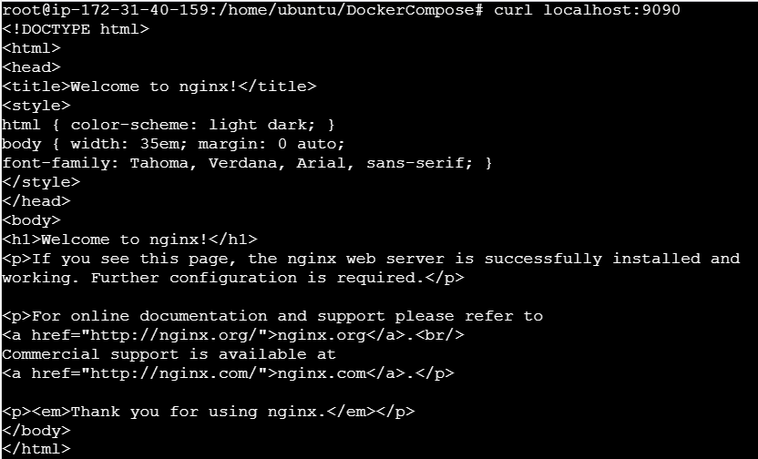

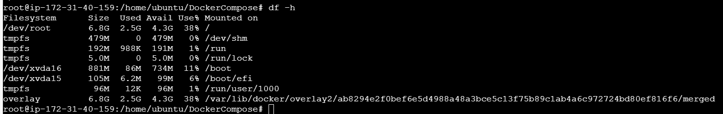

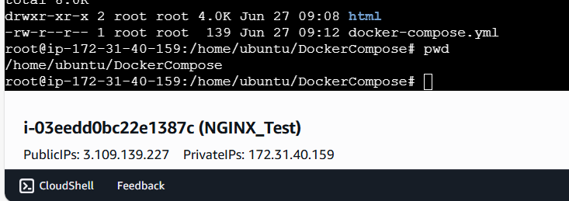

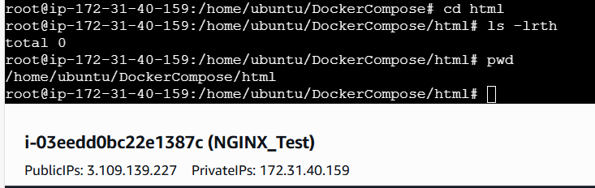

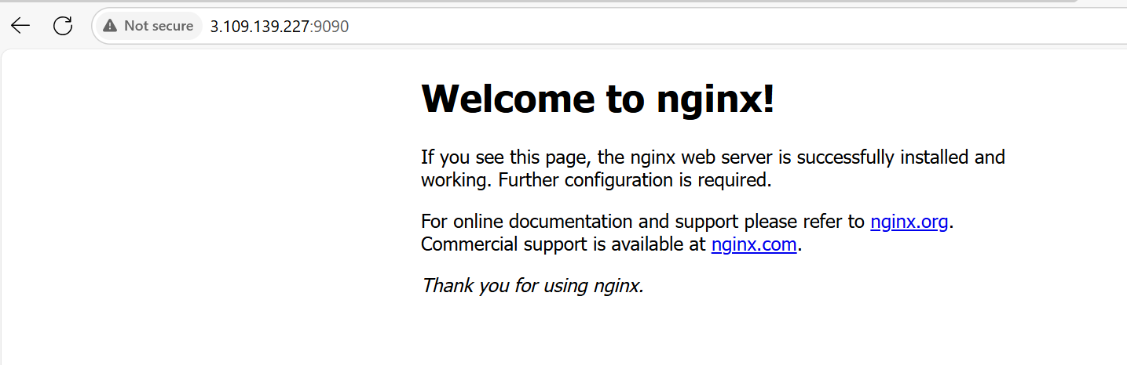

Push the created custom docker image to your docker-hub: -

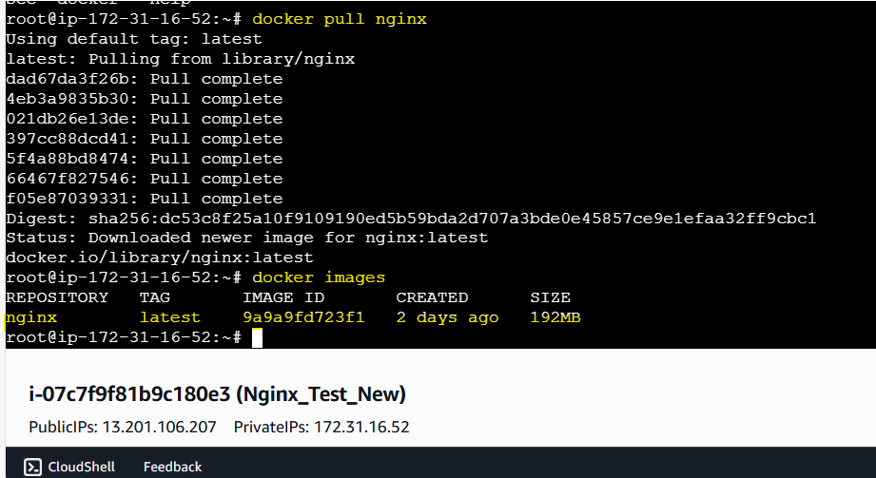

- Change the tag name to V1 from latest using the below command,
docker tag <imageid> <Newimagename:Tagname>
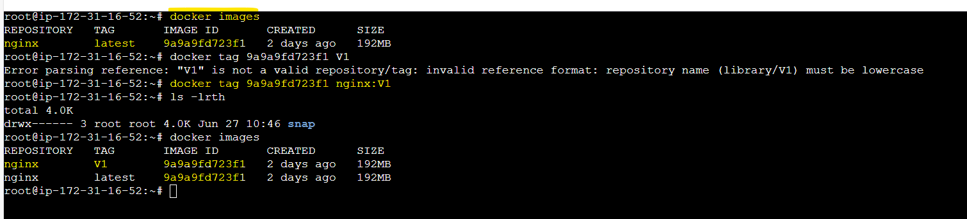

- Login to docker hub from EC2 using the below command,
Command is docker login -u <dockerhub username>
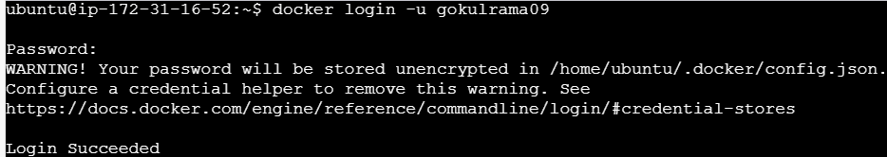

- Push docker image from EC2 to docker hub using the below command,
